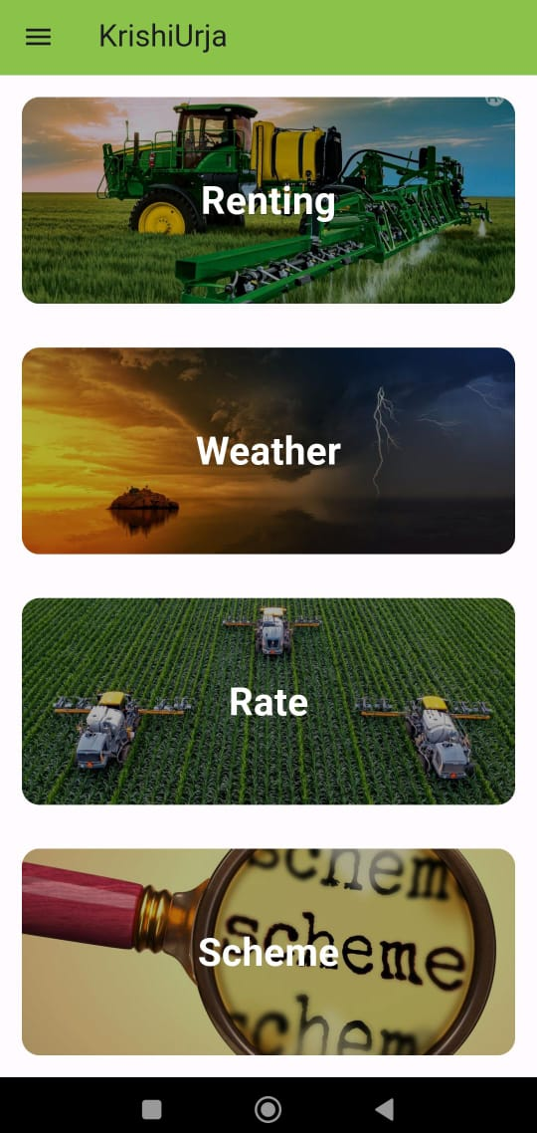

“ KrishiUrja ”

Cummins College of Engineering for Women, Nagpur

Akanksha Padgilwar, Kajal Katheriya, Siddhika Mundada

Department of Computer Engineering

**METHODOLOGY**

**OBJECTIVE**

**-Prof. Sharayu Deote**

**FLOW CHART**

**CONCLUSION**

**RESULT**

**SCREENS**

**PROBLEM STATEMENT**

**INTRODUCTION**

**ABSTRACT**

The Maharashtra agricultural uplift initiative integrates modern machinery rental, information dissemination on crops and weather, and climate-resilient practices. Targeting challenges like irrigation and market access, it aims to elevate farmers' incomes and ensure food security. Collaboration with stakeholders is key to its success in revitalizing Maharashtra's agricultural sector.

KrishiUrja is a transformative platform designed to tackle India's agricultural challenges head-on. By providing farmers with crucial resources such as weather forecasts, access to machinery, market intelligence, and information on government schemes, it empowers them to make informed decisions.

Through the integration of technology and training initiatives, KrishiUrja enhances farmers' productivity and enables them to adapt to dynamic agricultural landscapes. Ultimately, this comprehensive approach fosters prosperity and sustainability within the agricultural sector, promising a brighter future for farmers and the industry as a whole.

To rejuvenate Maharashtra's agricultural sector by implementing a multifaceted strategy focused on uplifting farmers' livelihoods. This includes facilitating access to modern agricultural machinery, establishing an information dissemination system, promoting climate-resilient farming practices, and fostering collaboration among stakeholders to enhance productivity, increase incomes, and fortify food security across the region.

The implemented system allows seamless access to modules like machine rental, weather forecasts, and grain prices. Farmers benefit from accessing modern equipment, accurate weather predictions, and market insights, enhancing farming efficiency and decision-making for improved agricultural outcomes in Maharashtra.



KrishiUrja, a mobile app, tackles farmers' challenges by offering machine rentals, weather forecasts, grain prices, and government schemes information. Developed using Flutter, Dart, and Firebase, it ensures a seamless user experience. By providing vital information, KrishiUrja enhances farmers' decision-making, boosts crop yield, and uplifts India's agriculture sector.



Problem Statement: The agricultural sector in Maharashtra faces significant challenges, including limited access to modern machinery, inadequate information on crop rates and weather forecasts, and a lack of adoption of climate-resilient farming practices. These obstacles hinder farmers' productivity, income, and food security. Collaborative efforts are needed to address these issues and revitalize Maharashtra's agricultural landscape.

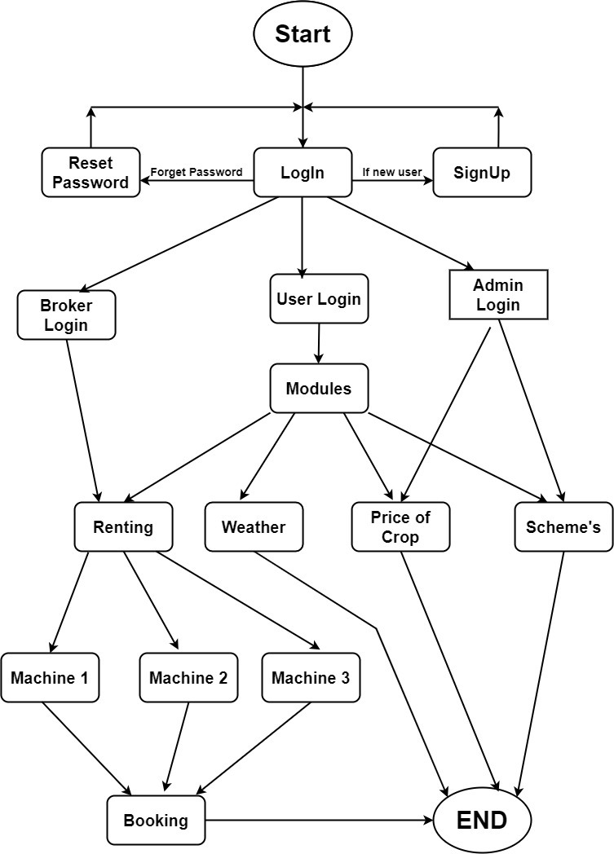



The proposed system requires internet access for registration and login. After authentication, users explore modules like machine rental, weather forecasts, and grain prices. The machine rental module facilitates access to modern farming equipment. The weather module provides accurate forecasts, aiding in farming planning. The grain cost module assists farmers in making informed selling decisions.